Toran Installation Guide

Toran is a stand-alone application for Windows (lgudpsw.exe), or Linux (lgudps) which will listen for logger communication on a UDP port and create data files of logged data sent by loggers.

This guide covers installing and configuring Toran manually onto a Windows or Linux PC, and automatically onto a Windows PC during a Radwin Installation.

Document History:
Edition | Date of Issue | Modification | Notes
1st | 14/01/2013
2nd | 19/05/2014 | Added Linux installation notes
3rd | 02/09/2014 | Added Radwin installation notes

Windows Installation
- Ensure you have full Administrator rights for the PC/Server you wish to install the Application on.
- You may also wish to consider temporarily stopping any anti-virus software running in the background.
- The Application uses port 23024 (default) for UDP communication with the logger. Any Firewalls or ACLs on the network will need to be configured appropriately.
- Create a suitable folder for Toran and place the application (lgudpsw.exe) into that folder.
- Run the application.
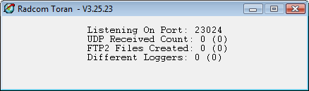
- The counts are for today with the figures in brackets for yesterday.
- At this time, the application will be listening on the default UDP port of 23024 and default folders will have been created in the Toran folder.
- If you wish to change any of the configurable settings, you will need to close the application and edit the “lgudpsw.ini” file which will have been created in Toran folder. You can edit the settings with a text editor such as Notepad or Wordpad.
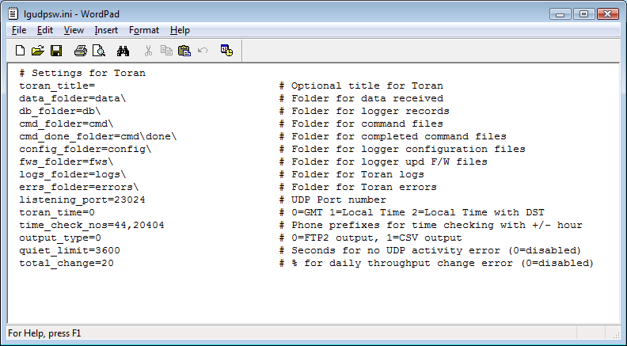

Radwin Toran Installation

Toran is included with the installation of Radwin v4.68 and later. Toran will be automatically installed into the ‘Toran’ subfolder off the radwin installation folder. Startup links are provided in the Windows Start group 'Radlog For Windows', and from the 'Start' menu within Radwin programs.
- Ensure you have full Administrator rights for the PC/Server you wish to install Radwin on.
- You may also wish to consider temporarily stopping any anti-virus software running in the background.
- The Application uses port 23024 (default) for UDP communication with the logger. Any Firewalls or ACLs on the network will need to be configured appropriately.
- Install Radwin V4.68 or later.
- Run Toran from any of the Radwin Toran Links.
- The counts are for today with the figures in brackets for yesterday.
- At this time, the application will be listening on the default UDP port of 23024 and default folders will have been created in the Toran folder.
- If you wish to change any of the configurable settings, you will need to close the application and edit the “lgudpsw.ini” file which will have been created in Toran folder. You can edit the settings with a text editor such as Notepad or Wordpad.

Configure Radwin to receive GPRS data from Toran
- In Radwin System Configuration (Radwin Setup, Options menu, System Configuration…) select the 'Autocall Ports' page.
- Select a com port to be used for receiving GPRS data from Toran from the list. This can be any port number. Double click the port in the list to configure it.
- Enable the port by selecting the 'Enable Port' check box.
- Select the 'Connection Type' as 'GPRS from Folder' from the drop down list.
- Enter the Toran data folder in the 'Folder' entry fied - this is the Toran 'data_folder' ( see 'Settings For Toran' )
- Select OK to accept the changes and return to the Autocall Ports page.
- Select OK to Save the updated System Configuration.
- Start Radwin Auocall to process GPRS data received by Toran.
Debian Linux Installation
- Ensure you sufficient rights for the Linux PC/Server you wish to install the Application on.
- The Application uses port 23024 (default) for UDP communication with the logger. Any Firewalls on the network will need to be configured appropriately.
- Create a suitable folder for Toran and place the executable file (lgudps) into that folder.
- Run the application by typing lgudps
- At this time, the application will be listening on the default UDP port of 23024 and default folders will have been created in the Toran folder.
- If you wish to stop the application you can type Ctrl-C in the command window.
- If you wish to change any of the configurable settings, you will need to stop the application and edit the “lgudpsw.ini” file which will have been created in Toran folder. You can use any text editor such as vim or nano.

Settings For Toran

toran_title= # Optional title for Toran

This setting allows you to add some text to the Toran title and is particularly useful if you are running more than one instance of Toran and need to distinguish between them.

data_folder=data\ # Folder for data received

This is the folder for the logged data from the loggers.

db_folder=db\ # Folder for logger records

This is the folder which holds the logger configuration record for each logger as a separate .hdr file.

cmd_folder=cmd\ # Folder for command files

This is where command files can be placed to update the logger’s configuration. The command files can be created with a suitable application.

cmd_done_folder=cmd\done\ # Folder for completed command files

When one of the command files has been completed, it is moved to this folder.

config_folder=config\ # Folder for logger configuration files

This folder can contain commands to be sent to a logger in the event that it sends a ‘Config Corrupt’ status.

fws_folder=fws\ # Folder for logger upd F/W files

With the appropriate command sent to a logger, it can request a F/W update to one of the F/Ws stored, in ‘udp’ format, in this folder.

logs_folder=logs\ # Folder for Toran logs

This folder contains a daily log of the raw UDP traffic in a file named “udp – yymmdd.log” and a monthly log of Toran activity in a file named “Toran_yyyymm.csv”.

errs_folder=errors\ # Folder for Toran errors

This folder contains a log of individual “Toranxxxx.err” files which will be created on the following errors:
- Logger request for non existent firmware file
- Daily total has changed significantly
- Too quiet

listening_port=23024 # UDP Port number

This is the port which Toran listens for logger UDP traffic.

toran_time=0 # 0=GMT 1=Local Time 2=Local Time with DST

This is the setting which allows you to select which time the loggers should be running at.

0 – The loggers will be run at GMT.
1 – The loggers will be run at the local time set by the computer.
2 – The loggers will be run at the local time set by the computer and will follow the PC time when it switches to Daylight Saving Time (DST).

time_check_nos=44,20404 # Phone prefixes for time checking with +/- hour

This setting allows the time control set by toran_time (above) to apply only to certain logger phone numbers. The setting is a comma separated list of phone number prefixes. If the prefix matches the beginning of the logger number, then the logger time will be controlled by Toran according to the toran_time setting. An offset can be applied to the time indicated by toran_time by including a ‘+’ or ‘–‘ number of hours offset after the number prefix.

e.g. With toran_time=0 and time_check_nos=44+1,20404 then the logger numbers with a prefix 44 would get there time set to GTM + 1 hour and numbers beginning 20404 would be set to GMT.

output_type=0 # 0=FTP2 output, 1=CSV output

This is where the format is set for the logged data which will be output to the data_folder.

0 – The ftp2 format is a proprietary HWM format and its definition is covered by document:

“DOC-130-020 (MultiLog GPRS FTP File type 2).doc”

The filenames are “FTP2+nnnnnnnnnnn_yymmddhhmmssxxxxx.txt”.

1 – The CSV output is in the following format:

Date ,Time ,Ch 1 ,Ch 2 ,Ch 3
22/12/13,12:15:00, 62.800, 0.055, 29.400
22/12/13,12:30:00, 62.800, 0.056, 29.400
22/12/13,12:45:00, 62.900, 0.053, 29.400
22/12/13,13:00:00, 63.000, 0.053, 29.400
22/12/13,13:15:00, 63.100, 0.055, 29.300
22/12/13,13:30:00, 63.200, 0.054, 29.400
22/12/13,13:45:00, 63.300, 0.053, 29.400

The filenames are “nnnnnnnnnn_yymmddhhmmssxxxxx.csv” with flow data in units of ‘l/s’ and pressure in units of ‘m’.

In the filename, ‘nnnnnnnnnnnn’ is the logger phone number, ‘yymmddhhmmss’ is the date and time of processing, and ‘xxxxx’ is a count.

quiet_limit=3600 # Seconds for no UDP activity error (0=disabled)

This is a setting which controls the generation of an error in the errs_folder when a UDP packet has not been received in the last quiet_limit seconds. To disable this check, the quite_limit should be set to 0.

total_change=20 # % for daily throughput change error (0=disabled)

This is a setting which controls the generation of an error in the errs_folder when the number of data files produced in the data_folder has changed from the previous day by a percentage greater than that set by the total_change settings. To disable this check, the total_change should be set to 0.

