**QUOTATION**

Number : 2024984447

Date : 10.10.2024

Internal Sales : Stefan S

Phone / Fax : +6261-8461136

+6281807878178

To : Mr. Habibi

Company : PDAM TIRTANADI

Phone / Fax : +6261-4571666

Dear Mr. Habibi,

Thank you very much for your enquiry.

We are pleased to give our quotation matching your application requirements as follow,



* Price exclude PPN

Should you wish to discuss any aspect of our offer, please do not hesitate to contact us.

We look forward to receiving your valued order.

With kind regards

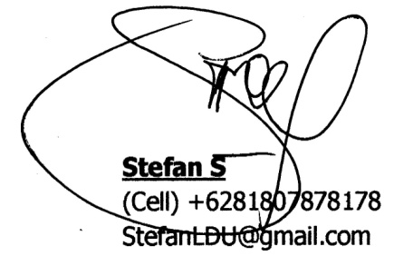

**Stefan S**

(Cell) +6281807878178

StefanLDU@gmail.com